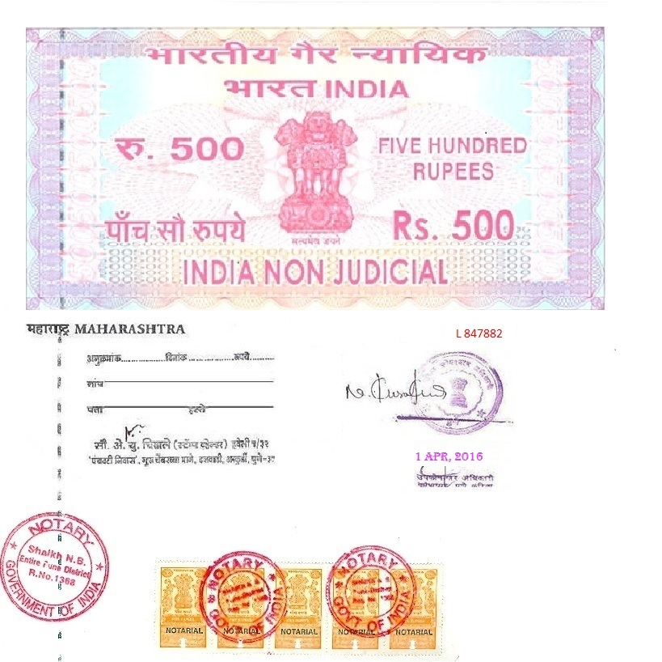

AGREEMENT

This Agreement is made and entered in this 1st day of APR, 2016 between
Mr. Khatavkar Suresh Bhoskar
Age 38 years, Occupation – Service,
#Groud Floor, Shree Sai Samarth Row house, Tuljabhavani Nagar,sno 55/2, Kharadi, Pune - 411014

Hereinafter referred to as "Landlord"

- Mr. Pavan Tiwari
04, Jatibai Apt., Sundrel road,
Dhamnod, Dhar, Madhya Pradesh - 454552

Hereinafter referred to as "Tenant".

WHEREAS, Landlord desires to lease to Tenant and Tenant
desires to lease from Landlord the premises generally described
as

“#First Floor, Shree Sai Samarth Row house, Tuljabhavani Nagar,sno 55/2, Kharadi, Pune - 411014”

It is herein agreed as follows:


- Landlord hereby leases to Tenant, the furnished premises described above for a term of 11 Months beginning on Apr 1, 2016 and ending on Mar 1, 2017, at a monthly rate of 13,000/- (Thirteen Thousand Rupees Only).

- The described premises are leased furnished, to include all furnishes enumerated on the List of Furnishings, which is a part of this lease, signed by both parties and dated.

- Tenant agrees to pay the rent herein provided subject to the terms and conditions set forth herein.

- Rent shall be payable in equal monthly installments on or before 5th day of each month, to the address of Landlord as stated above or at such other address as Landlord may, from time to time, require.

- Tenant shall pay for electricity during the term of this lease and any
extension or renewal thereof.

6. Landlord covenants that the leased premises are, to the best of his
knowledge, clean, safe, sound and healthful and that there exists no
violation of any applicable housing code, law or regulation of which he
is aware.

7. Tenant agrees to comply with all sanitary laws, ordinances and rules
affecting the cleanliness, occupancy and preservation of the
premises during the term of this lease.

- Tenant shall use the leased premises exclusively for a private residence for occupancy by no more than 3 persons, unless otherwise specified herein, and Tenant shall not make any alterations to the house, outbuildings or grounds without written consent of Landlord.

- Tenant shall keep the premises in good order and repair and shall advise Landlord or Landlord's agent of any needed repairs or maintenance

- Tenant agrees to take good care of the furniture, draperies, appliances and other household goods, and the personal effects of Landlord, and further agrees that he will deliver up same to Landlord in good condition at the end of the term of this lease, normal wear and tear expected.

- Tenant shall repair or replace, at Tenant's expense, all loss or damage to any of the listed furniture, draperies, appliances and other household goods, and personal effects of Landlord, whenever such damage or loss shall have resulted from Tenant's misuse, waste or neglect of said furnishings and personal effects of Landlord.

- Tenant shall cause to be made, at Tenant's expense, all required repairs to electric and gas fixtures and plumbing work whenever such damage shall have resulted from misuse, waste or neglect of Tenant, it being understood that Landlord is to have same in good order and repair when giving possession.

- Tenant shall not keep or have in or on the leased house, outbuildings or grounds any article or thing of a dangerous, flammable or explosive nature that might be pronounced "hazardous" or extra hazardous" by any responsible insurance company.

- Landlord covenants that the Tenant and Tenant's family shall have, hold and enjoy the leased premises for the term of this lease, subject to the conditions set forth herein.

- Tenant covenants that he shall not commit nor permit a nuisance in or upon the premises, that he shall not maliciously or by reason of gross negligence damage the house, outbuildings or grounds, and that he shall not engage, nor permit any member of his family to engage, in conduct so as to interfere substantially with the comfort and safety of residents of adjacent buildings.

- Tenant shall, at reasonable times, give access to Landlord or his agents for any reasonable and lawful purpose. Except in situations of compelling emergency, Landlord or his agents shall give the Tenant at least 24 hours' notice of intention to seek access, the date and time at which access will be sought, and the reason therefore.

- In the event of default by Tenant, Tenant shall remain liable for all rent due or to become due during the term of this lease. Landlord or his agents shall have the obligation to relet the premises in the Landlord's name for the balance of the term, or longer, and will apply proceeds of such reletting toward the reduction of Tenant's obligations enumerated herein.

- Tenant shall permit Landlord or his agents to show the premises at reasonable hours, to persons desiring to rent or purchase same, 30 days prior to the expiration of this lease, and will permit the notice "To Let" or "For Sale" to be placed on said premises and remain thereon without hindrance or molestation after said date.

- In the event of any breach by the Tenant of any of Tenant's covenants or agreements herein, Landlord or his agents may give Tenant five days' notice to cure said breach, setting forth in writing which covenants or agreements have been breached. If any breach is not cured within said five-day period, or reasonable steps to effectuate said cure are not commenced and diligently pursued within said five-day period and thereafter until said breach has been cured, Landlord or his agents may terminate this lease upon five days' additional notice to the Tenant, with said notice being in lieu of a Notice to Quit, which Tenant hereby waives. Said termination shall be ineffective if Tenant cures said breach or commences and diligently pursues reasonable steps to effectuate such cure at any time prior to the expiration of said five-day termination. Upon terminating this lease as provided herein, Landlord or his agent may commence proceedings against Tenant for his removal as provided for by law.

- In the event of any breach by Landlord of any of Landlord's covenants or agreements herein, Tenant may give Landlord ten days' notice to cure said breach, setting forth in writing the manner in which said covenants and agreements have been breached. If said breach is not cured within said ten-day period, or reasonable steps to effectuate said cure are not commenced and diligently pursued within said ten-day period and thereafter until said breach has been cured, rent hereunder shall be fully abated from the time at which said ten days' notice expired until such time as Landlord has fully cured the breach set forth in the notice provided for in this paragraph.

- In no case shall any abatement of rent hereunder be effected where the condition set forth in the notice provided for herein was created by the intentional or negligent act of the Tenant, but Landlord shall have the burden of proving that rent abatement may not be effected for the foregoing reason.

- Landlord agrees to deliver possession of the leased premises at the beginning of the term provided for herein. In the event of Landlord's failure to deliver possession at the beginning of said term, Tenant shall have the right to rescind this lease and recover any consideration paid under terms of this Agreement.

- Tenant agrees that this lease shall be subject to and subordinate to any mortgage or mortgages now on said premises or which any owner of said premises may hereafter at any time elect to place on said premises.

- This lease constitutes the entire agreement between the parties hereto. No changes shall be made herein except by writing, signed by each party and dated. The failure to enforce any right or remedy
hereunder, and the payment and acceptance of rent hereunder,
shall not be deemed a waiver by either party of such right or remedy
in the absence of a writing as provided for herein.


- In the event legal action is required to enforce any provision of this agreement, the prevailing party shall be entitled to recovery reasonable attorney's fees and costs.

- Landlord and Tenant agree that this lease, when filled out and signed, is a binding legal obligation.

List of Furnishings


- Three Fans
- Six Tubes
- Three Chairs

Signed before the under mentioned witnesses.

(Mr.Khatavkar Suresh Bhoskar)

LICENSOR

LICENSEE:

Pavan Tiwari
Witnesses:-

1. Signature:-
Name :- Sachin Shivaji Powar
Address :- Kharadi, Pune

2. Signature:-
Name :- Laxman Nagtilak
Address :- Dapodi, Pune

